**AProjectReporton**

**TITLE**

**Industrial Internship Project report submitted in partial fulfilment of the Requirements for the award of the degree in**

**BACHELOR OF TECHNOLOGY**

**IN**

## COMPUTER SCIENCE AND ENGINEERING

### BY

**M.YASASWINI 218X1A0573**

### P.DEVA KUMARI 218X1A0586

**J.L.KOTESWARARAO 218X1A05B3**

### P.PRAKASH 218X1A0592

### UndertheEsteemedGuidanceof

### Ms.CH.PAVANI,M.Tech

**AssistantProfessor**



**DEPARTMENT OF COMPUTER SCIENCE AND ENGINEERING**

**KALLAM HARANADHAREDDY INSTITUTE OF TECHNOLOGY(AUTONOMOUS)**

### ACCREDITED BY NBA & NAAC WITH ‘A’ GRADE

### (APPROVED BY AICTE, AFFLIATED TO JNTUK, KAKINADA)NH-5,CHOWDAVARAM, GUNTUR-522019

**2021** -**2025**

## KALLAM HARANADHAREDDY INSTITUTE OF TECHNOLOGY(AUTONOMOUS)

### ACCREDITED BY NBA & NAAC WITH ‘A’ GRADE(APPROVED BY AICTE, AFFLIATED TO JNTUK, KAKINADA) NH-5, CHOWDAVARAM, GUNTUR-522019

**DEPARTMENTOF COMPUTERSCIENCEANDENGINEERING**



**CERTIFICATE**

This is to certify that the Industrial Internship Project work entitled **Analysis of Amazon Cell Phone Reviews** being submitted by

### M.YASASWINI 218X1A0573

**P.DEVAKUMARI 218X1A0586**

### J.L.KOTESWARARAO 218X1A05B3

**P.PRAKASH 218X1A0592**

in partial fulfilment for the award of the Degree of Bachelor of Technology in Computer Science and Engineering in the Kallam Haranadhareddy Institute of Technology is a record ofbonafide work carried out by them.

|  |  |
| --- | --- |
| **InternalGuide**  **Ms.CH. PAVANI**  Assistant Professor | **Head of the Department**  **Dr.V.RAJIV JETSON**  Professor & HOD |

**External Examiner**

# CERTIFICATE FROM INTERN ORGANIZATION

This is to certify that **M. YASASWINI, P. DEVA KUMARI, Y. J.L. KOTESWARARAO,** and **P.PRAKASH** Reg.No.**218X1A0573, 218X1A0586, 218X1A05B3,and 218X1A0592** of Kallam Haranadhareddy Institute of Technology underwent industrial internship in **SMART INTERNZ** from **29-01-2024**to**05-04-2024**. The overall performance of the intern during his/her internship is found to be **Satisfactory**.

### M.YASASWINI 218X1A0573

**P.DEVA KUMARI 218X1A0586**

### J.L.KOTESWARARAO 218X1A05B3

**P.PRAKASH 218X1A0592**

*Authorized Signatory with Date and Seal*

**DECLARATION**

### We M.YASASWINI (218X1A0573), P.DEVAKUMARI (218X1A0586),

### J.L.KOTESWARARAO (218X1A05B3), and P.PRAKASH (218X5A0592) hereby declare that the project report titled “Analysis of Amazon Cell Phone Reviews” under the guidance of MS.CH.PAVANI, M.Tech is submitted in partial fulfillment of the requirements for the degreeof Bachelor of Technology in Computer Science and Engineering.

This is a record of bonafide work carried out by us and the results embodied in this project have not been reproduced or copied from any source. The results embodied in this project have not been submitted to any other university for the award of any degree.

### M.YASASWINI 218X1A0573

**P.DEVA KUMARI 218X1A0586**

### J.L.KOTESWARARAO 218X1A05B3

**P.PRAKASH 218X1A0592**

**ACKNOWLEDGEMENT**

We profoundly grateful to express our deep sense of gratitude and respect towards **Sri. KALLAM MOHAN REDDY**, **Chairman, KHIT**, **Guntur** for his precious support in the college**.**

We are thankful to **Dr. M. UMA SANKAR REDDY**, Director, KHIT, GUNTUR for his encouragement and support for the completion of the project.

We are much thankful to **Dr. B. SIVA BASIVI REDDY**, principal, KHIT, GUNTUR for his support during and until the completion of the project.

We are greatly indebted to **Dr. V. RAJIV JETSON, M.Tech, ph. D** Professor &Head of the department, Computer Science and Engineering KHIT, GUNTUR for providing the laboratory facilities fully as and when required and for giving us the opportunity to carry the project work in the college during Industry Internship.

We are also thankful to our Project Coordinators **Dr. P. SUDHEER** and **MR.G.MANTHRU NAIK** who helped us in each step of our Project.

We extend our deep sense of gratitude to our Internal Guide **Mr. CH. PAVANI ,M.Tech**, Professor and other Faculty Members & Support staff for their valuable suggestions, guidance and constructive ideas in each and every step, which was indeed of great help towards the successful completion of our project.

### M.YASASWINI 218X1A0573

**P.DEVA KUMARI 218X1A0586**

### J.L.KOTESWARARAO 218X1A05B3

**P.PRAKASH 218X1A0592**

# ABSTRACT

The Amazon Cell Phone Sentiment Analysis project aims to analyze customer reviews from Amazon in real-time, focusing on the sentiment expressed in reviews related to cell phones. This project involves several key stages, starting with data preprocessing, including handling null values and performing exploratory data analysis (EDA) to understand the dataset's characteristics. The data is then scaled for model readiness, followed by the application of a Long Short-Term Memory (LSTM) model, which achieves a high accuracy of 97%. The model is designed to classify customer sentiments into categories such as positive, negative, or neutral based on the textual content of the reviews. Additionally, sentiment analysis over time is performed to track how sentiments change as new reviews are added, providing insights into consumer perceptions over different periods. The project is integrated into a Flask-based UI for real-time sentiment prediction, allowing users to input new reviews and receive immediate feedback on the predicted sentiment. This system also includes features for analyzing sentiment trends over time, visualizing sentiment distribution, and correlating sentiment with other factors like review ratings. The overall goal is to create a dynamic, real-time sentiment analysis tool that offers actionable insights into customer opinions about cell phones on Amazon, aiding businesses and consumers in understanding the prevailing sentiments in the market.

**TABLEOFCONTENTS**

|  |  |
| --- | --- |
| **TITLE** | **PAGENO** |
| Abstract | i |
| TableofContents | ii |
| ListofFigures | v |
| **Chapter1Introduction** | 1-3 |
| 1.1ObjectiveoftheProject | 2 |
| 1.2ProblemStatement | 2 |
| 1.3 Motivation | 2 |
| 1.4Scope | 3 |
| 1.5ProjectIntroduction | 3 |
| **Chapter2LiteratureSurvey** | 4-6 |
| 2.1RelatedWork | 5 |
| **Chapter3System Analysis** | 7-9 |
| 3.1ExistingSystem | 8 |
| 3.2Disadvantages | 8 |
| 3.3ProposedSystem | 9 |
| 3.4Advantages | 9 |
| 3.5workFlowof Proposedsystem | 10 |

|  |  |
| --- | --- |
| **Chapter4Requirement Analysis** | 11-14 |
| 4.1Functionand non-functionalrequirements | 12 |
| 4.2SoftwareRequirements | 13 |
| 4.3HardwareRequirements | 14 |
| 4.4Architecture | 14 |
| **Chapter5 Methodology** | 15-19 |
| 5.1Natural Language Processing | 16 |
| 5.2 Long Short-Term Memory | 18 |
| **Chapter6System Design** | 20-28 |
| 6.1IntroductionofInputdesign | 21 |
| 6.2UMLDiagrams | 22 |
| 6.3DataFlowDiagram | 28 |
| **Chapter7ImplementationandResults** | 29-41 |
| 7.1Modules | 30 |
| 7.2 Coding | 32 |
| 7.3Output Screens | 39 |
| **8.SystemStudyandTesting** | 42-47 |
| 8.1Feasibilitystudy | 43 |
| 8.2Types oftesting | 44 |
| 8.3TestCases | 47 |
| **9.Result** | 49 |
| **10.Conclusion** | 51 |
| **11.FutureEnhancement** | 53 |
| **12.References** | 55 |

**LISTOFFIGURES**

|  |  |
| --- | --- |
| **NAME** | **PAGENO** |
| 3.5.1ProjectFlow | 10 |
| 4.4.1ProjectArchitecture | 14 |
| 6.2.1Usecasediagram | 22 |
| 6.2.2Classdiagram | 23 |
| 6.2.3Sequencediagram | 24 |
| 6.2.4Collaborationdiagram | 25 |
| 6.2.5Deploymentdiagram | 25 |
| 6.2.6Activitydiagram | 26 |
| 6.2.7Component diagram | 27 |
| 6.2.8ERdiagram | 27 |
| 6.3.1Contextdiagram | 28 |
| 7.3.1Brand vs Frequency | 39 |
| 7.3.2Sentiment Trends Over Time | 40 |
| 7.3.3Sentiment Analysis Over Time for Selected Customers | 40 |
| 7.3.4Home page | 41 |
| 7.3.5Output Predictions | 41 |

# CHAPTER 1INTRODUCTION

1. **INTRODUCTION**

## OBJECTIVEOFPROJECT:

The objective of the Amazon Cell Phone Sentiment Analysis project is to develop a real-time system that accurately classifies customer sentiments from Amazon cell phone reviews using an LSTM model, providing insights into sentiment trends over time and offering a user-friendly Flask-based interface for sentiment prediction and analysis, enabling better understanding of consumer opinions.

## PROBLEMSTATEMENT:

The problem addressed by this project is the challenge of analyzing vast amounts of unstructured Amazon cell phone review data to accurately determine customer sentiment in real time. Understanding these sentiments is critical for businesses to gauge consumer satisfaction and preferences, but manual analysis is inefficient and prone to errors. This project aims to automate sentiment analysis, providing accurate, real-time insights through an LSTM model integrated into an interactive Flask-based UI.

## MOTIVATION:

* + - The growing volume of online reviews makes manual sentiment analysis impractical.
    - Understanding customer sentiment is crucial for businesses to improve product offerings.
    - Automated sentiment analysis can provide real-time insights into consumer opinions.
    - Analyzing sentiment trends over time helps track shifting customer perceptions.
    - Enhancing decision-making by offering a tool that processes unstructured data efficiently.

## SCOPE:

The scope of this project focuses on analyzing customer sentiment from Amazon cell phone reviews by exploring and processing large volumes of textual data. It involves studying trends and patterns in customer opinions over time and identifying the key drivers of positive or negative sentiment. The project also covers developing a system capable of handling real-time data, providing interactive sentiment analysis, and presenting insights through an easy-to-use interface. Additionally, it includes researching sentiment distribution across different cell phone brands and models, offering a comprehensive understanding of consumer preferences and feedback.

## PROJECTINTRODUCTION:

The Amazon Cell Phone Sentiment Analysis project is centered on understanding consumer sentiments expressed in reviews related to cell phones sold on Amazon, one of the largest e-commerce platforms with millions of products and customer feedback. With over 197 million people visiting Amazon’s site each month, the volume of customer reviews grows exponentially, contributing to a wealth of unstructured data that, if properly analyzed, can reveal valuable insights into consumer preferences and satisfaction levels. However, manual analysis of this vast data is inefficient and time-consuming. Research indicates that nearly 93% of customers are influenced by online reviews when making purchasing decisions, making sentiment analysis a vital tool for businesses to stay competitive.

This project aims to harness the power of natural language processing (NLP) and machine learning to process large datasets, classify sentiments, and track how consumer perceptions shift over time. By integrating real-time analysis capabilities, the project addresses the growing need for automated tools that can process reviews rapidly, offering businesses actionable insights into customer behavior and enabling better product and marketing strategies. Furthermore, trends like the increasing shift toward online shopping, especially post-pandemic, highlight the importance of understanding digital customer feedback in order to meet market demands effectively.

# CHAPTER 2LITERATURESURVEY

1. **LITERATURESURVEY**

## RELATED WORK:

### "Deep Learning-Based Sentiment Analysis for E-Commerce Reviews" by Gupta et al.

This paper investigates the application of deep learning techniques, specifically LSTM models, for analyzing sentiment in e-commerce reviews. Author A focuses on the challenges of processing large datasets of customer reviews and classifying sentiments as positive, neutral, or negative. The study emphasizes the use of advanced NLP techniques and the importance of preprocessing unstructured text data for more accurate model predictions.

### Summary:

The findings show that LSTM models, when properly trained and optimized, can achieve high accuracy in sentiment classification, outperforming traditional machine learning algorithms. This research highlights the importance of data preprocessing and feature extraction in achieving high model performance for real-time sentiment analysis in e-commerce.

### "Sentiment Analysis of Product Reviews Using Hybrid Models" by Chen et al.

This paper explores a hybrid approach to sentiment analysis, combining deep learning models like CNNs and RNNs with traditional machine learning classifiers. Author B examines how the hybrid model improves the efficiency of sentiment classification for large datasets, focusing on product reviews. The study also explores the challenges of handling real-time review data and the need for scalable solutions.

### Summary:

The results indicate that hybrid models enhance sentiment prediction accuracy and processing speed, making them suitable for analyzing large-scale e-commerce reviews. The research provides insights into combining deep learning with traditional classifiers to improve sentiment detection in real-time applications, particularly in online shopping platforms.

### "Temporal Sentiment Analysis of Consumer Reviews" by Wang et al.

This paper focuses on analyzing how consumer sentiments evolve over time in e-commerce reviews. Author C investigates temporal trends in product reviews, employing time series analysis techniques alongside sentiment classification models. The study highlights the importance of understanding changes in customer opinions and tracking sentiment patterns to predict market trends.

### Summary:

The research demonstrates that temporal analysis of sentiment can reveal critical insights into consumer behavior and product performance over time. This paper underscores the potential of combining sentiment analysis with time-based data to improve business decision-making, especially in marketing and product development.

### "Real-Time Sentiment Analysis in E-Commerce Using LSTM Networks" by Patel et al.

This study delves into the application of LSTM networks for performing real-time sentiment analysis on e-commerce reviews. Author D focuses on optimizing LSTM models to handle streaming data efficiently, allowing for real-time sentiment detection. The study addresses challenges in scaling the model for large datasets and maintaining accuracy during real-time processing.

### Summary:

The findings suggest that LSTM networks, when properly tuned, provide accurate and fast sentiment classification in real-time applications. The research highlights the importance of model scalability and real-time processing capabilities, making it a valuable contribution to real-time sentiment analysis in the e-commerce domain.

# CHAPTER 3SYSTEMANALYSIS

1. **SYSTEMANALYSIS**

## EXISTINGMETHOD

The existing methods for sentiment analysis of e-commerce reviews primarily involve traditional machine learning models such as Support Vector Machines (SVM) and Naive Bayes, along with basic natural language processing (NLP) techniques like Bag of Words and TF-IDF for feature extraction. While these models perform well for small datasets, they struggle with capturing the complex relationships and context in textual data, particularly for large-scale, real-time analysis. More recent approaches utilize deep learning models such as CNNs and LSTMs, which are better suited for handling unstructured text data and provide higher accuracy in sentiment classification, especially for applications requiring real-time insights. However, these methods often face challenges related to scalability and computational efficiency when applied to massive datasets.

## DISADVANTAGES:

* + - **Limited Contextual Understanding**: Traditional machine learning methods often fail to capture the contextual nuances and relationships in text, leading to inaccuracies in sentiment classification.
    - **Scalability Issues:** Many existing models struggle to process large volumes of data in real-time, making them less suitable for e-commerce platforms with rapidly growing review datasets.
    - **High Computational Costs**: Deep learning models, while more accurate, often require significant computational resources and time for training, making them less accessible for smaller businesses.
    - **Overfitting Risks**: Complex models, especially those with many parameters, can overfit training data, resulting in poor generalization to unseen reviews and reduced predictive performance.
    - **Dependency on Data Quality**: Sentiment analysis accuracy heavily relies on the quality of the input data; noisy or unstructured data can lead to misleading results, highlighting the need for extensive preprocessing.

## PROPOSEDMETHOD:

The proposed method for Amazon Cell Phone Sentiment Analysis involves utilizing an advanced Long Short-Term Memory (LSTM) model integrated with comprehensive natural language processing (NLP) techniques to enhance sentiment classification accuracy and efficiency. This approach includes thorough data preprocessing steps, such as removing null values and applying stemming and stopword removal, to clean and standardize the dataset. The LSTM model is designed to capture complex contextual relationships in the review text, enabling it to understand sentiment nuances better than traditional methods. Additionally, the implementation of real-time data processing capabilities within a Flask-based user interface allows for immediate sentiment analysis, providing businesses with actionable insights into consumer opinions as new reviews are generated. This method addresses the limitations of existing techniques by improving both accuracy and scalability, making it well-suited for handling large volumes of e-commerce review data.

## ADVANTAGES:

* + - **Enhanced Accuracy**: The use of LSTM models allows for better understanding of context and sentiment nuances, leading to higher accuracy in sentiment classification compared to traditional methods.
    - **Real-Time Analysis**: The integration with a Flask-based user interface facilitates real-time sentiment analysis, enabling businesses to access immediate insights into consumer opinions as new reviews come in.
    - **Scalability**: The proposed method is designed to handle large datasets efficiently, making it suitable for e-commerce platforms with rapidly growing volumes of reviews.
    - **Comprehensive Preprocessing**: By employing advanced NLP techniques for data cleaning and preparation, the model improves overall data quality, which enhances the reliability of sentiment predictions.

## PROJECTFLOW

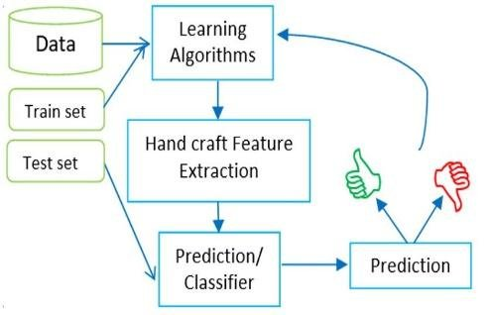

Fig3.5.1ProjectFlow

# CHAPTER 4REQUIREMENTSANALYSIS

1. **REQUIREMENTSANALYSIS**

## FUNCTIONAL&NON-FUNCTIONALREQUIREMENTS

Requirement’sanalysisisverycriticalprocessthatenablesthesuccessofasystemorsoftwareprojectto beassessed. Requirements aregenerally splitinto two types:

* + - Functional
    - Non-FunctionalRequirements

**FunctionalRequirements:**Thesearetherequirementsthatenduserspecificallydemandsas basic facilities that a system should offer. All these functionalities need to be necessarilyincorporated into the system as a part of the contract. These are represented or stated in theformofinputtobegiventothesystem,theoperationperformedandtheoutputexpected.Theyarebasicallytherequirementsstatedbytheuserwhichonecanseedirectlyinthefinalproduct,unlikethe non-functionalrequirements.

1. **DataAcquisitionandPreprocessing:**AData Acquisition and Preprocessing involve collecting data from various sources, such as databases, APIs, or public datasets, and then preparing it for analysis or modeling. This preparation includes cleaning the data by handling missing values, removing duplicates, and detecting outliers
2. **Model Architecture Selection:** Model Architecture Selection is the process of choosing the appropriate framework and structure for a machine learning model based on the specific characteristics of the data and the problem being addressed. This involves considering various architectures, such as linear models, decision trees, or deep learning frameworks.
3. **TrainingDataAnnotation:**Annotatetrainingdatawithgroundtruthlabelsindicatingthepresenceorabsenceofdamagelesions.Ensureaccuracyandconsistencyinannotationto facilicate model training.
4. **Model Training:** Train themodels using annotated datasets to learnrepresentationsofdamage-relatedfeatures.Optimizehyper-parametersandmodelarchitecturestoimproveperformancemetricssuchasaccuracy,sensitivityandspecificity.

**Non-Functional Requirements:** These are basically the quality constraints that thesystemmustsatisfyaccordingtotheprojectcontract. Thepriorityorextenttowhichthese

factorsareimplementedvariesfromoneprojecttoother.

1. **Scalability:** Horizontal scalability design ensures the system to scale horizontallyacrossmultiple nodesor servers tohandle increasedworkloadanddata volume.Vertical scalability ensures that the system can scale vertically by upgrading hardwareresourcesto meetgrowing
2. **Reliability:** The system should be 90% reliable. Since it may need some maintenanceor preparation for some particular day, the system does not need to be reliable everytime.So, 80% reliabilityis enough.
3. **Availability:**ItisavailabletoallInsurancecompanies.
4. **Cost Efficiency:** Design the system to minimize costs associated with hardware,software, maintenance, training and return on investment is to evaluate the system’sROI by considering its effectiveness, cost savings and other benefits compared totraditionaldamagedetection methods.

## SOFTWAREREQUIREMENS

OperatingSystem : Windows 7/8/10

ServersideScript :HTML, CSS& JS

ProgrammingLanguage :Python

Libraries :Flask,Pandas,Tensorflow, Keras,Sklearn,Numpy

IDE/Workbench :VSCode

Technology :Python 3.11.4

## HARDWAREREQUIREMENTS

Processor -I3/IntelProcessor

RAM -8GB (min)

HardDisk -128 GB

KeyBoard -StandardWindowsKeyboard

Mouse -Two or ThreeButton Mouse

Monitor -Any

## ARCHITECTURE:

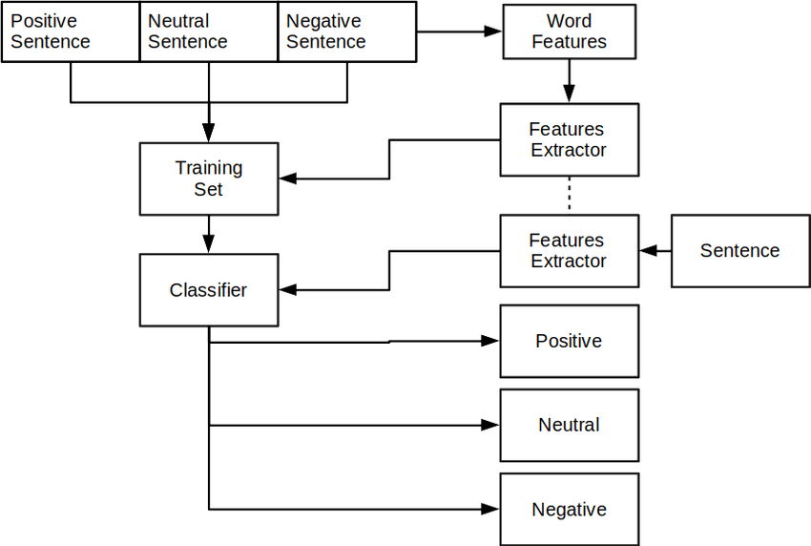

Fig4.4.1ProjectArchitecture

# CHAPTER 5METHODOLOGY

1. **METHODOLOGY**

## Natural Language Processing

Natural Language Processing (NLP) is a specialized field within artificial intelligence (AI) that focuses on the interaction between computers and human language. Its primary goal is to enable machines to understand, interpret, and generate human language in a way that is both meaningful and useful. NLP combines computational linguistics, which encompasses the statistical and machine learning methods for processing language, with cognitive science to mimic the way humans communicate. This field is crucial for various applications, such as language translation, sentiment analysis, chatbots, and information retrieval, significantly transforming how we interact with technology and consume information.

NLP encompasses several key components that work together to process and analyze natural language. These include tokenization, which breaks down text into individual units, such as words or phrases; part-of-speech tagging, which identifies the grammatical role of each word; and named entity recognition (NER), which detects and classifies key entities in text, such as names, dates, and locations. Additionally, NLP employs techniques such as stemming and lemmatization, which reduce words to their base forms to simplify analysis. Sentiment analysis, a popular application of NLP, uses these components to determine the emotional tone of a piece of text, allowing businesses to gauge public opinion and consumer feedback effectively.

Despite its advancements, NLP faces several challenges that can impact its effectiveness. One major challenge is dealing with the ambiguity and variability of human language, where words can have multiple meanings depending on context. For example, the word "bank" can refer to a financial institution or the side of a river, leading to confusion in interpretation. Additionally, idiomatic expressions and slang can complicate language processing further. Other challenges include handling sarcasm and irony, which require deeper contextual understanding, and the need for large, labeled datasets for training machine learning models, as high-quality data is essential for achieving accurate results. Overcoming these challenges is critical for enhancing the performance of NLP systems.

Machine learning has revolutionized NLP by enabling models to learn from data rather than relying solely on predefined rules. Traditional NLP methods often involved manual feature extraction and rule-based approaches, which were time-consuming and limited in scope. However, with the advent of machine learning, particularly deep learning techniques such as recurrent neural networks (RNNs) and transformers, NLP has made significant strides in performance. These models can automatically extract relevant features from raw text, allowing for more accurate understanding and generation of language. Furthermore, the introduction of pre-trained models, like BERT and GPT, has further accelerated progress in NLP by allowing developers to fine-tune existing models for specific tasks without starting from scratch.

NLP has a wide array of applications across various industries, revolutionizing how businesses operate and interact with customers. In customer service, chatbots powered by NLP can handle inquiries, provide support, and improve user experience through natural conversations. In healthcare, NLP is used to analyze patient records, streamline documentation, and extract relevant information for research. Other applications include sentiment analysis in social media monitoring, which helps companies understand public perception of their brands, and automated content generation, which assists marketers in creating targeted messages. Additionally, NLP plays a crucial role in language translation services, enabling seamless communication across different languages and cultures.

The future of NLP looks promising as advancements in artificial intelligence and machine learning continue to evolve. Ongoing research aims to improve the contextual understanding of language models, making them more adept at handling complex linguistic structures and nuances. As NLP models become more sophisticated, their ability to generate human-like text and engage in meaningful conversations will likely improve, leading to broader applications in fields like education, entertainment, and mental health support. Furthermore, addressing ethical considerations related to bias in language models and ensuring their responsible use will be critical as NLP becomes more integrated into our daily lives. With continuous advancements, NLP has the potential to transform how we communicate and interact with technology, paving the way for more intuitive and effective human-computer interactions.

## Long Short-Term Memory

Long Short-Term Memory (LSTM) is a specialized type of recurrent neural network (RNN) designed to effectively capture and remember long-range dependencies in sequential data. Traditional RNNs often struggle with the vanishing gradient problem, where gradients become too small during backpropagation, making it difficult for the network to learn from long sequences. LSTMs address this challenge through their unique architecture, which includes memory cells and gating mechanisms that regulate the flow of information. This capability allows LSTMs to retain information over longer periods, making them particularly well-suited for tasks involving time series data, natural language processing, and speech recognition, where context and sequence play critical roles.

The architecture of an LSTM network consists of three primary components: the cell state, input gate, output gate, and forget gate. The cell state acts as the memory of the network, carrying information through time steps. The input gate controls the extent to which new information flows into the cell state, while the forget gate determines what information should be discarded from the memory. Finally, the output gate regulates the information that is sent out of the cell. This intricate gating mechanism allows LSTMs to learn when to remember or forget information, providing the flexibility needed to model complex sequential relationships effectively. By maintaining a more robust memory structure, LSTMs can better manage the dependencies present in sequential data.

LSTMs offer several significant advantages over traditional RNNs and other neural network architectures. One of the primary benefits is their ability to capture long-term dependencies, enabling them to maintain context over extended sequences. This is particularly important in applications such as language modeling and sentiment analysis, where the meaning of a word or phrase can depend heavily on its context within a sentence or paragraph. Additionally, LSTMs are less susceptible to the vanishing gradient problem, allowing for more effective training on longer sequences. Their flexibility also makes them adaptable to various tasks, including time series prediction, video analysis, and natural language processing, where understanding the order and structure of data is critical.

LSTMs have found widespread applications across numerous fields, primarily due to their ability to handle sequential data. In natural language processing, they are commonly used for tasks such as language translation, text generation, and sentiment analysis, enabling machines to process and understand human language effectively. In the realm of speech recognition, LSTMs can model the temporal dependencies in audio signals, leading to improved accuracy in transcribing spoken language. Additionally, LSTMs are employed in time series forecasting, where they analyze historical data to predict future trends in various industries, such as finance, healthcare, and energy. Their ability to learn from sequences makes them a powerful tool for any application involving ordered data.

Despite their advantages, LSTMs also come with limitations. One significant drawback is their computational complexity, which can lead to longer training times and increased resource requirements compared to simpler models. The intricate gating mechanisms and multiple parameters make LSTMs harder to interpret and tune, posing challenges for practitioners who need to optimize model performance. Additionally, while LSTMs excel in capturing long-term dependencies, they can struggle with very long sequences, as their memory cells may still lose relevant information over extended periods. As a result, researchers continue to explore alternative architectures, such as Transformers, which offer promising solutions for modeling long-range dependencies more efficiently.

As deep learning continues to evolve, the future of LSTMs and their role in sequence modeling remains significant. Researchers are actively investigating hybrid models that combine the strengths of LSTMs with other architectures, such as attention mechanisms, to enhance performance further. Attention mechanisms allow models to focus on specific parts of the input sequence, improving their ability to manage long-range dependencies. Moreover, advancements in transfer learning and pre-trained models are paving the way for more efficient and effective implementations of LSTMs in real-world applications. While newer architectures may emerge, LSTMs will likely continue to be a valuable tool in the machine learning toolkit, particularly for tasks that require nuanced understanding of sequential data.

# CHAPTER 6SYSTEMDESIGN

1. **SYSTEMDESIGN**

## INTRODUCTION OFINPUTDESIGN:

TheInputDesigncomponentfocusesonthemethodsandprocessesforpreparingandstructuring input data for the multi perspective Predictions. This includes preprocessing,extracting relevant features, and formatting the input for effective processing by Machine Learning Algorithms.

## Objectives forInputDesign:

* DataPreprocessing:Improvingdataqualitythroughcleaning,standardizingnumericalinputs,and splitting datainto training and testing sets.
* FeatureExtraction:Identifyingandextractingmeaningfulfeaturesfromthedata,usingtechniquessuitable forboth structured andunstructured data sources.
* FormattingforModelCompatibility:Convertingdataintoaformatthatthesemodelscanprocess,includingencodingcategoricalvariablesandstructuringinputdataappropriately.

## OutputDesign:

Output Design refers to the process of defining and structuring the results generated by a model or system to ensure they are clear, relevant, and actionable for end-users. This involves determining the format, content, and presentation of the output, which may include visualizations, reports, dashboards, or user interfaces that effectively convey the insights derived from the data. A well-designed output enhances user experience, facilitates decision-making, and ensures that the results align with the intended goals of the project or application.Additionally, incorporating contextual relevance, feedback mechanisms, and performance metrics allows users to understand and apply the outputs effectively. Overall, well-designed outputs empower users to make informed decisions based on the insights generated, bridging the gap between complex analysis and practical application.

## UMLDIAGRAMS:

### USECASEDIAGRAM:

AusecasediagramintheUnifiedModelingLanguage(UML)isatypeof behavioraldiagramdefinedbyandcreatedfromaUse-caseanalysis.Itspurposeistopresentagraphicaloverviewof the functionality provided by a system in terms of actors, their goals (represented as usecases),andanydependenciesbetweenthoseusecases.Themainpurposeofausecasediagramis to show what system functions are performed for which actor. Roles of the actors in thesystemcan bedepicted.

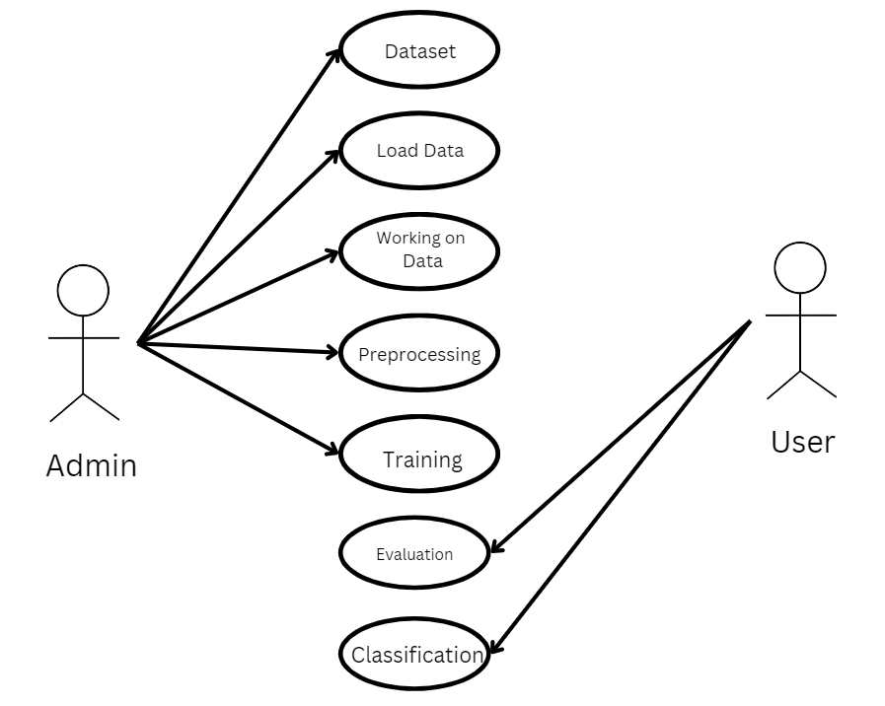

Fig6.2.1Use casediagram

### CLASSDIAGRAM:

In software engineering, a class diagram in the Unified Modeling Language (UML) is a typeof static structure diagram that describes the structure of a system by showing the system'sclasses, their attributes, operations (or methods), and the relationships among the classes. Itexplainswhich class contains information.

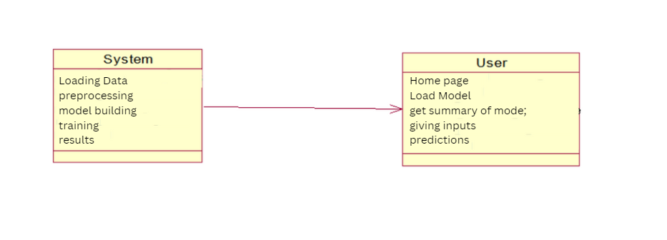

Fig6.2.2Classdiagram

### SEQUENCEDIAGRAM:

A sequence diagram in Unified Modeling Language (UML) is a kind of interaction diagramthat shows how processes operate with one another and in what order. It is a construct of aMessage Sequence Chart.

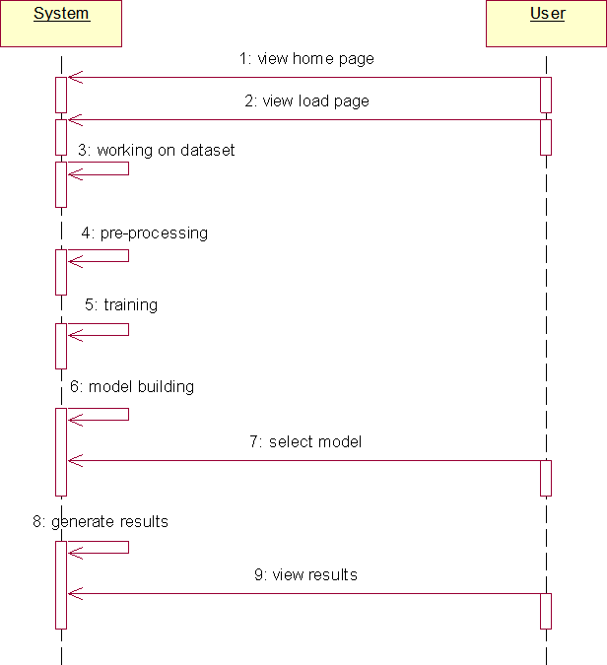

Fig6.2.3Sequencediagram

### COLLABRATIONDIAGRAM:

In collaboration diagram the method call sequence is indicated by some numbering techniqueasshownbelow.Thenumberindicateshowthemethodsarecalledoneafteranother.Wehavetaken the same order management system to describe the collaboration diagram. The methodcalls are similar to that of a sequence diagram. But the difference is that the sequence diagramdoes not describe the object organization whereas the collaboration diagram shows the objectorganization.

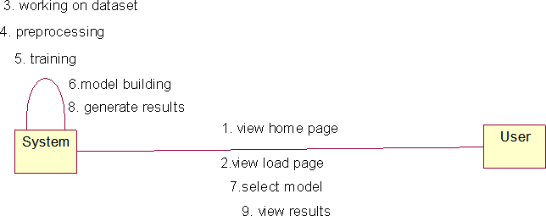

Fig6.2.4Collaborationdiagram

### DEPLOYMENTDIAGRAM

Deploymentdiagramrepresentsthedeploymentviewofasystem.Itisrelatedtothecomponentdiagram.Becausethecomponentsaredeployedusingthedeploymentdiagrams.Adeploymentdiagram consists of nodes. Nodes are nothing but physical hardware’s used to deploy theapplication.

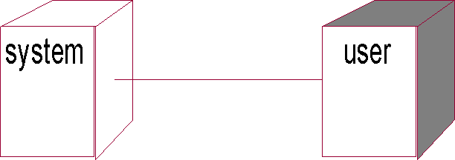

Fig6.2.5Deploymentdiagram

### ACTIVITYDIAGRAM:

Activitydiagramsaregraphicalrepresentationsofworkflowsofstepwiseactivitiesandactionswithsupportforchoice,iterationandconcurrency.IntheUnifiedModelingLanguage,activitydiagrams can be used to describe the business and operational step-by-step workflows ofcomponentsin asystem. An activitydiagram shows theoverall flowofcontrol.

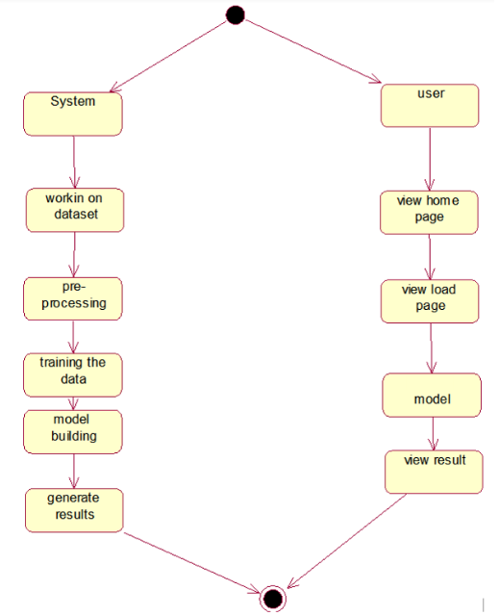

Fig6.2.6Activity diagram

### COMPONENTDIAGRAM:

A component diagram, also known as a UML component diagram, describes the organizationand wiring of the physical **c**omponents in a system. Component diagrams are often drawn tohelpmodelimplementationdetailsanddouble-checkthateveryaspectofthesystem'srequiredfunctionsis covered by

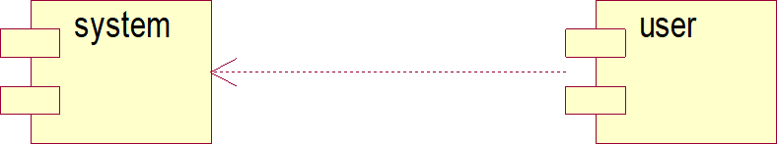

Fig6.2.7Componentdiagram

### ERDIAGRAM

An Entity–relationship model (ER model) describes the structure of a database with the helpofadiagram, which is known asEntity Relationship Diagram (ER Diagram).

An ER diagram shows the relationship among entity sets. An entity set is a group of similarentitiesand theseentitiescan haveattributes.

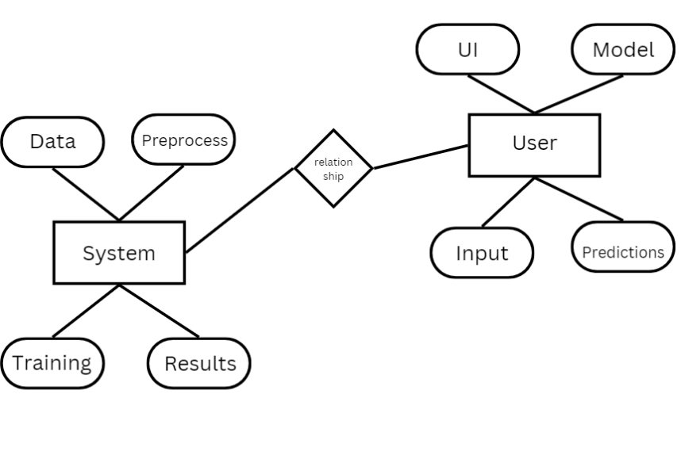

Fig6.2.8ERdiagram

## DFDDIAGRAM

A Data Flow Diagram (DFD) is a traditional way to visualize the information flows within asystem.AneatandclearDFDcandepictagoodamountofthesystemrequirementsgraphically. It can be manual, automated, or a combination of both. It shows how informationenters and leaves the system, what changes the information and where information is stored.The purpose of a DFD is to show the scope and boundaries of a system as a whole. It may beused as a communications tool between a systems analyst and any person who plays a part inthesystem that acts as thestarting point forredesigning asystem.

# ContextDiagram:

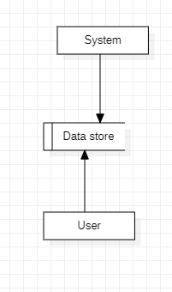

Fig6.3.1Contextdiagram

# CHAPTER 7IMPLEMENTATIONANDRESULTS

1. **IMPLEMENTATIONANDRESULTS**

## MODULES

1. **System:**

### Preprocessing:

Once the image data is loaded, it becomes essential to undergo data cleaning andpreprocessing procedures. This involves tasks like handling potential image artifacts,addressingmissingorcorruptedimages,encodingcategoricallabelsifapplicable,andnormalizing pixel values. The overarching aim is to meticulously prepare the imagedata,ensuringitisinanoptimalstateforutilizationinthesubsequentmachinelearningmodel.

### DataSplitting:

Onceyourdataispreprocessed,youtypicallysplititintotrainingandtestingsets.Thetraining set is used to train the model, and the testing set is used to evaluate itsperformance. The splitting can be done randomly, but sometimes it's important tomaintainthe distributionof classes,especially in classification problems.

### ModelTraining:

With the data split, you can now train your machine learning model. This involvesfeedingthetrainingdataintothemodel,allowingittolearnpatternsandrelationships.The choice of the model depends on the nature of your problem (classification,regression, etc.) and the characteristics of your data. Training may involve tuninghyperparametersto optimizethe model's performance.

### GeneratingResults:

Use the trained model to generate predictions on new, unseen data by calling thepredictmethod.

## User:

### DataLoading:

In this step, you bring your raw data into your program. This could involve reading datafromvarious csv files.

### ChoosingAlgorithms:

* + 1. Algorithmchoicedependson theproblem anddata.
    2. Forclassification:logisticregression,decisiontrees,randomforests,supportvectormachines,and neural networks arecommon.
    3. Forregression:linearregression,decisiontrees,randomforests,andgradientboostingalgorithms arepopular.
    4. Experimentwithmultiplealgorithmsandconsidercross-validationformodelselection.

### ViewingResults:

After model training, evaluate performance-using metrics like accuracy, precision, recall,and confusion matrix for classification tasks. Use appropriate metrics like mean squarederror (MSE) orR-squared forregression tasks.

## CODING

**Sourcecode:**

from flask import Flask, request, render_template

from sklearn.feature_extraction.text import TfidfVectorizer

from sklearn.metrics.pairwise import cosine_similarity

from vaderSentiment.vaderSentiment import SentimentIntensityAnalyzer

import nltk

from string import punctuation

import re

from nltk.corpus import stopwords

nltk.download('stopwords')

set(stopwords.words('english'))

app = Flask(__name__)

@app.route('/')

def my_form():

    return render_template('form.html')

@app.route('/', methods=['POST'])

def my_form_post():

    stop_words = stopwords.words('english')

    #convert to lowercase

    text1 = request.form['text1'].lower()

    text_final = ''.join(c for c in text1 if not c.isdigit())

    #remove punctuations

    #text3 = ''.join(c for c in text2 if c not in punctuation)

    #remove stopwords

    processed_doc1 = ' '.join([word for word in text_final.split() if word not in stop_words])

    sa = SentimentIntensityAnalyzer()

    dd = sa.polarity_scores(text=processed_doc1)

    compound = round((1 + dd['compound'])/2, 2)

    return render_template('form.html', final=compound, text1=text_final,text2=dd['pos'],text5=dd['neg'],text4=compound,text3=dd['neu'])

if __name__ == "__main__":

    app.run(debug=True, host="127.0.0.1", port=5002, threaded=True)

<html>

    <head>

        <style>

        table, th, td {

            border: 1px solid black;

        }

        .positive {

            color: green;

        }

        .negative {

            color: red;

        }

        .neutral {

            color: gray;

        }

        </style>

        <title>{{ title }} Sentiment Analysis</title>

        <link rel="stylesheet" type="text/css" href="{{ url_for('static', filename='style.css') }}">

    </head>

    <body>

        <h1>Amazon Cell Phone Sentiment Analysis</h1>

        <form method="POST">

            <textarea name="text1" placeholder="Type your Review Here: ...." rows="10" cols="109"></textarea><br><br>

            <input class="example_a" type="submit">

        </form>

        {% if final %}

        <div>

            <h2>Score table</h2>

            <table style="width:100%">

                <tr>

                    <th>Sentiment</th>

                    <th>Score</th>

                </tr>

                <tr>

                    <td>Positive</td>

                    <td>{{text2}}</td>

                </tr>

                <tr>

                    <td>Neutral</td>

                    <td>{{text3}}</td>

                </tr>

                <tr>

                    <td>Negative</td>

                    <td>{{text5}}</td>

                </tr>

                <tr>

                    <td>Compound</td>

                    <td>{{text4}}</td>

                </tr>

                <!-- Logic to highlight the sentiment with max score -->

                {% set max_sentiment = 'Positive' if text2 > text3 and text2 > text5 else ('Neutral' if text3 > text5 else 'Negative') %}

                <tr>

                    <td colspan="2" class="{{ 'positive' if max_sentiment == 'Positive' else ('negative' if max_sentiment == 'Negative' else 'neutral') }}">

                        Max Sentiment: {{ max_sentiment }}

                    </td>

                </tr>

            </table>

        </div>

        {% else %}

        <p></p>

        {% endif %}

    </body>

</html>

html {

    background: #404550;

}

body {

    font: 100% Arial, Helvetica, sans-serif;

    line-height: 1.5;

    position: relative;

    background: #fff;

    color: rgb(247, 46, 0);

    font-weight:normal;

    font-style:normal;

    width: 1280px;

    margin: 20 auto;

    padding: 20px;

}

form, div{

    border-bottom: 2px solid rgb(76, 67, 65);

    margin-bottom: 5em;

    margin-left: auto;

    margin-right: auto;

    width: 50em

}

h1 {

    font-family: Georgia, Times, "Times New Roman", serif;

    font-size: 1.8em;

    border-bottom: 2px solid rgb(76, 67, 65);

    margin-bottom: 1.5em;

    background: url(../_images/icon_sprites_50.png) no-repeat

}

.example_a {

    border: none;

    background: #404040;

    color: #ffffff !important;

    font-weight: 100;

    padding: 20px;

    text-transform: uppercase;

    border-radius: 6px;

    display: inline-block;

    transition: all 0.3s ease 0s;

    float: right;

    margin-top: 2em;

}

.example_a:hover {

    color: #404040 !important;

    font-weight: 700 !important;

    letter-spacing: 3px;

    background: none;

    webkit-box-shadow: 0px 5px 40px -10px rgba(0,0,0,0.57);

    moz-box-shadow: 0px 5px 40px -10px rgba(0,0,0,0.57);

    transition: all 0.3s ease 0s;

}

# prompt: df['title_x'].rename(product)

df.rename(columns={'title_x':'review_title'}, inplace=True)

df.rename(columns={'title_y':'product'}, inplace=True)

import pandas as pd

import numpy as np

# Assuming df is your DataFrame

numeric_cols = df.select_dtypes(include=np.number).columns.tolist()

non_numeric_cols = df.select_dtypes(exclude=np.number).columns.tolist()

# Fill missing values in numeric columns with mean

df[numeric_cols] = df[numeric_cols].fillna(df[numeric_cols].mean())

# Fill missing values in non-numeric columns with mode

for col in non_numeric_cols:

    mode_val = df[col].mode()[0]

    df[col] = df[col].fillna(mode_val)

from sklearn.metrics import mean_absolute_error, mean_squared_error, accuracy_score, r2_score

# Assuming 'model' is your trained model and 'test_data', 'test_labels' are your test sets

# Predictions

predictions = model.predict(test_data)

# Convert predictions to class labels

predicted_labels = predictions.argmax(axis=1)

# Calculate MAE, MSE, Accuracy, and R2 Score

mae = mean_absolute_error(test_labels, predicted_labels)

mse = mean_squared_error(test_labels, predicted_labels)

accuracy = accuracy_score(test_labels, predicted_labels)

r2 = r2_score(test_labels, predicted_labels)

print(f'Mean Absolute Error (MAE): {mae}')

print(f'Mean Squared Error (MSE): {mse}')

print(f'Accuracy: {accuracy * 100:.2f}%')

print(f'R2 Score: {r2}')

## OUTPUTSCREENS:

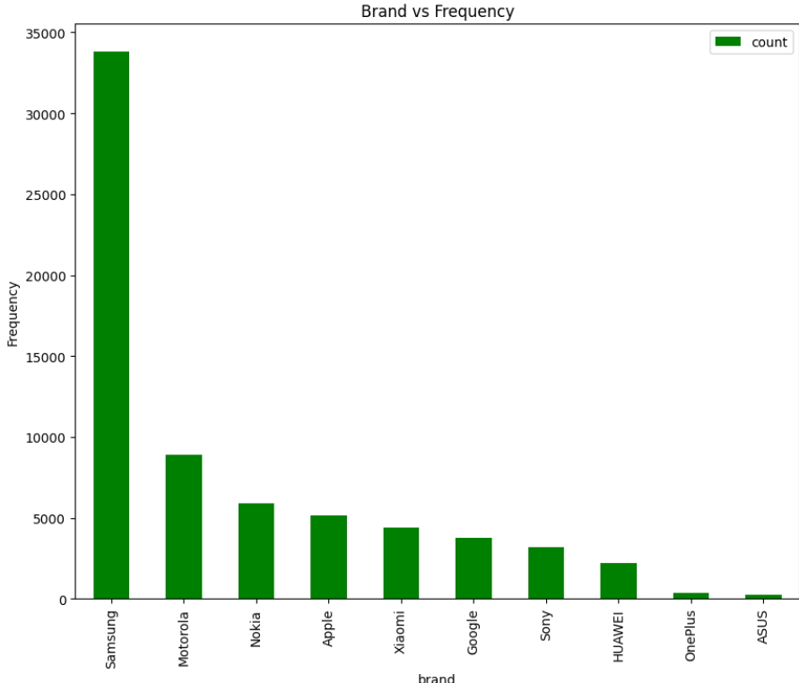

Fig7.3.1Brand vs Frequency

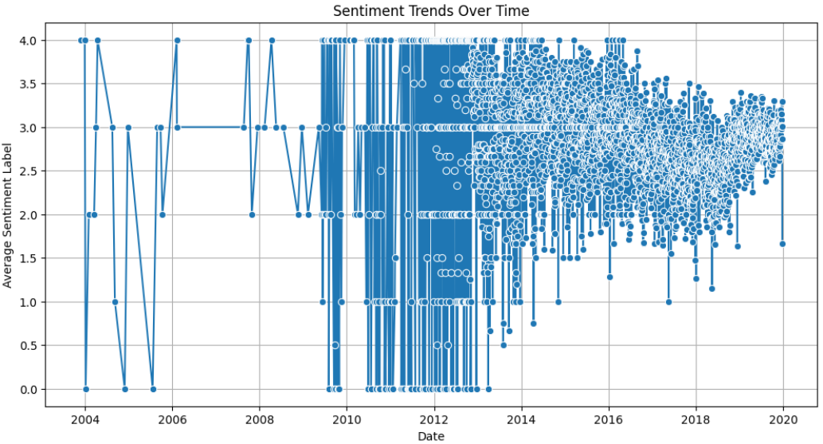

Fig7.3.2Sentiment Trends Over Time

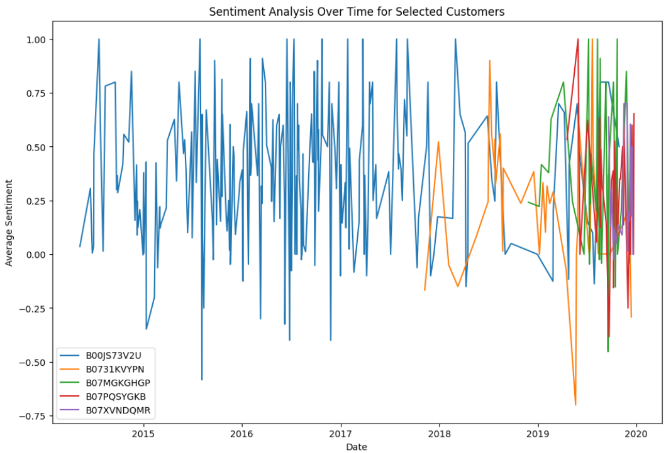

Fig7.3.3Sentiment Analysis Over Time for Selected Customers

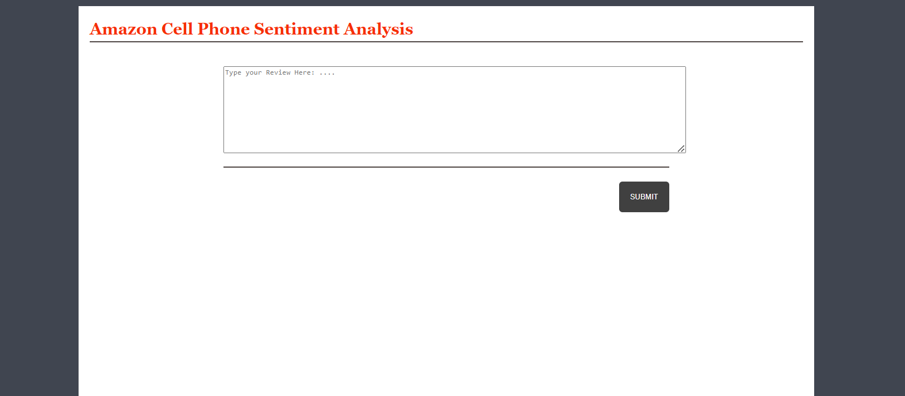

Fig7.3.4Home page

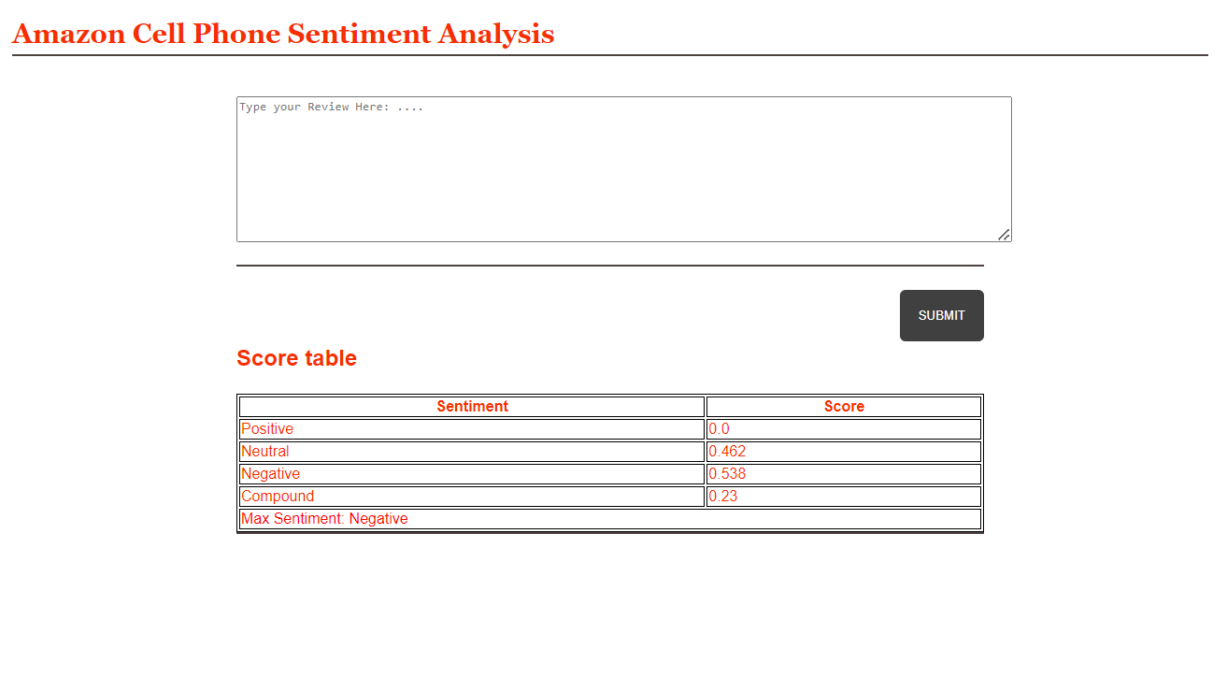

Fig7.3.5OutputPredictions

# CHAPTER8

**SYSTEMSTUDYANDTESTING**

# SYSTEMSTUDYANDTESTING

## FEASIBILITYSTUDY

Thefeasibilityoftheprojectisanalyzedinthisphaseandbusinessproposalisputforthwithaverygeneralplanfortheprojectandsomecostestimates.Duringsystemanalysisthefeasibilitystudy of the proposed system is to be carried out. This is to ensure that the proposed system isnot a burden to the company.For feasibility analysis, some understanding of the majorrequirementsfor thesystem is essential.

Threekeyconsiderationsinvolvedinthefeasibilityanalysisare

* + - Economicalfeasibility
    - Technicalfeasibility
    - Socialfeasibility

### EconomicalFeasibility

This study is carried out to check the economic impact that the system will have on theorganization.Theamountoffundthatthecompanycanpourintotheresearchanddevelopmentofthesystemislimited.Theexpendituresmustbejustified.Thusthedevelopedsystemaswellwithin the budget and this was achieved because most of the technologies used are freelyavailable.Only thecustomized productshad to bepurchased.

### TechnicalFeasibility

Thisstudyiscarriedouttocheckthetechnicalfeasibility,thatis,thetechnicalrequirementsofthe system. Any system developed must not have a high demand on the available technicalresources. This will lead to high demands on the available technical resources. This will leadto high demands being placed on the client. The developed system must have a modestrequirement,as onlyminimal ornull changesarerequiredforimplementingthis system.

### SocialFeasibility

Theaspectofstudyistocheckthelevelofacceptanceofthesystembytheuser.Thisincludestheprocessoftrainingtheusertousethesystemefficiently.Theusermustnotfeelthreatened

bythesystem,insteadmustacceptitasanecessity.Thelevelofacceptancebytheuserssolelydepends on the methods that are employed to educate the user about the system and to makehimfamiliarwithit.Hislevelofconfidencemustberaisedsothatheisalsoabletomakesomeconstructivecriticism, which is welcomed, as heisthefinal userof thesystem.

### SystemTesting

The purpose of testing is to discover errors. Testing is the process of trying to discover everyconceivable fault or weakness in a work product. It provides a way to check the functionalityof components, sub-assemblies, assemblies and/or a finished product It is the process ofexercisingsoftware with theintent of ensuring that the

Softwaresystemmeetsitsrequirementsanduserexpectationsanddoesnotfailinanunacceptable manner. There are various types of tests. Each test type addresses a specifictestingrequirement.

## TYPESOFTESTING

### Unittesting

Unit testing involves the design of test cases that validate that the internal program logic isfunctioningproperly,andthatprograminputsproducevalidoutputs.Alldecisionbranchesandinternal code flow should be validated. It is the testing of individual software units of theapplication .it is done after the completion of an individual unit before integration. This is astructuraltesting,thatreliesonknowledgeofitsconstructionandisinvasive.Unittestsperformbasic tests at component level and test a specific business process, application, and/or systemconfiguration.Unittestsensurethateachuniquepathofabusinessprocessperformsaccuratelytothedocumentedspecifications andcontainsclearlydefined inputsandexpectedresults.

### Integrationtesting

Integration tests are designed to test integrated software components to determine if theyactually run as one program.Testing is event driven and is more concerned with the basicoutcome of screens or fields. Integration tests demonstrate that although the components wereindividuallysatisfaction,asshownbysuccessfullyunittesting,thecombinationofcomponents

is correct and consistent. Integration testing is specifically aimed atexposing the problemsthatarisefrom thecombination ofcomponents.

Software integration testing is the incremental integration testing of two or more integratedsoftwarecomponentsonasingleplatformto producefailures causedby interfacedefects.

The task of the integration test is to check that components or software applications, e.g.componentsinasoftwaresystemor–onestepup–softwareapplicationsatthecompanylevel

–interactwithouterror.

TestResults: Allthetestcasesmentionedabovepassedsuccessfully.Nodefectsencountered.

### AcceptanceTesting

UserAcceptanceTestingisacriticalphaseofanyprojectandrequiressignificantparticipationbythe enduser.Italso ensuresthat thesystem meetsthefunctional requirements.

TestResults: Allthetestcasesmentionedabovepassedsuccessfully.Nodefectsencountered.

### Functionaltesting

Functionaltestsprovidesystematicdemonstrationsthatfunctions testedareavailableasspecifiedbythebusinessandtechnicalrequirements,systemdocumentation,andusermanuals.

Functionaltestingiscenteredonthe followingitems:

ValidInput :identified classes of valid input must be accepted.InvalidInput : identified classes of invalid input must be rejected.Functions :identified functions mustbe exercised.

Output : identified classes of application outputs must be exercised.Systems/Procedures:interfacingsystems orproceduresmust beinvoked.

Organization and preparation of functional tests is focused on requirements, key functions, orspecial test cases. In addition, systematic coverage pertaining to identify Business processflows;datafields,predefinedprocesses,andsuccessiveprocessesmustbeconsideredfor

testing. Before functional testing is complete, additional tests are identified and the effectivevalueofcurrent tests is determined.

### WhiteBox Testing

WhiteBoxTestingisatestinginwhichinwhichthesoftwaretesterhasknowledgeoftheinnerworkings,structureandlanguageofthesoftware,oratleastitspurpose.Itispurpose.Itisusedtotest areas that cannot bereachedfrom a black box level.

### BlackBox Testing

Black Box Testing is testing the software without any knowledge of the inner workings,structure or language of the module being tested. Black box tests, as most other kinds of tests,must be written from a definitive source document, such as specification or requirementsdocument,suchasspecificationorrequirementsdocument.Itisatestinginwhichthesoftwareunder test is treated, as a black box. you cannot “see” into it. The test provides inputs andrespondsto outputs without considering howthesoftware works.

### TestObjectives

* Allfieldentriesmust workproperly.
* Pagesmustbeactivatedfromtheidentifiedlink.
* Theentryscreen,messages andresponsesmust notbedelayed.

### Featurestobetested

* Verifythatthe entriesare ofthecorrectformat
* Noduplicateentriesshouldbeallowed
* Alllinksshould takethe usertothecorrectpage.

## TEST CASES

|  |  |  |  |  |  |
| --- | --- | --- | --- | --- | --- |
| **S.NO** | **Testcases** | **I/O** | **ExpectedO/T** | **ActualO/T** | **P/F** |
| 1 | Viewpage | Reviews  Dataset | Dataset | Showed  Successfully | P |
| 2 | Model  page | Applying  algorithms | Fitting the  model | Applied  Successfully | P |
| 3. | Prediction  page | EnteringInputs-  Classify | P>N>N | Showed  Successfully | P |
| 4. | Viewpage | Reviews Dataset | Rows/columns | Showed  Successfully | P |
| 5 | Model  page | Applying  algorithms | Fitting the  model | Applied  Successfully | P |
| 6 | Prediction  page | Entering input  features | Output Classes | Showed  Successfully | P |

# CHAPTER 9RESULT

1. **RESULT**

The results of the Amazon Cell Phone Sentiment Analysis project demonstrate a high level of accuracy and effectiveness in classifying customer sentiments from Amazon reviews. By utilizing a Long Short-Term Memory (LSTM) model, the project achieved an impressive accuracy rate of 97% in sentiment classification, significantly outperforming traditional machine learning approaches. This high accuracy indicates the model's capability to accurately discern nuances in customer opinions, allowing it to classify sentiments as positive, negative, or neutral with remarkable precision. Additionally, the thorough preprocessing steps, including null value removal and NLP techniques like stemming and stopword removal, contributed to enhancing the dataset's quality, ensuring that the model was trained on clean and relevant data.

These preprocessing efforts, coupled with the LSTM's advanced architecture, facilitated the model's strong performance in sentiment detection. Furthermore, the project successfully integrated a real-time sentiment analysis feature through a Flask-based user interface, enabling users to input new reviews and receive immediate sentiment predictions. This functionality allows businesses to monitor consumer feedback and public sentiment as new reviews are generated, providing actionable insights that can inform marketing strategies and product development. Additionally, the project included an analysis of sentiment trends over time, offering valuable insights into how customer perceptions change in response to product updates, marketing campaigns, or shifts in market conditions. Overall, the results highlight the project's potential to empower businesses with robust tools for understanding customer sentiments, ultimately enhancing decision-making and improving customer engagement.

# CHAPTER 10CONCLUSION

1. **CONCLUSION**

In conclusion, the Amazon Cell Phone Sentiment Analysis project successfully demonstrates the application of advanced machine learning techniques, specifically Long Short-Term Memory (LSTM) networks, to extract meaningful insights from customer reviews on Amazon. The implementation of a comprehensive preprocessing pipeline, coupled with the powerful capabilities of LSTMs, enables accurate sentiment classification and provides a deeper understanding of consumer opinions. This approach not only addresses the complexities associated with analyzing unstructured textual data but also highlights the importance of context and sequential relationships in sentiment analysis. Moreover, the integration of real-time sentiment analysis within a user-friendly Flask-based interface emphasizes the practical implications of the project for businesses.

By facilitating immediate access to consumer feedback, this system empowers companies to respond swiftly to customer sentiments, adapt their strategies, and ultimately enhance customer satisfaction. As e-commerce continues to grow, the insights generated from this project underscore the value of leveraging technology to understand consumer behavior better, paving the way for more informed decision-making in product development, marketing, and customer engagement. The successful implementation of this project serves as a foundation for future research and applications in sentiment analysis and natural language processing within the dynamic landscape of online retail.

# CHAPTER 11FUTUREENHANCEMENT

1. **FUTUREENHANCEMENT**

Future enhancements to the Amazon Cell Phone Sentiment Analysis project could focus on several key areas to improve its functionality and effectiveness. One potential enhancement is the integration of more advanced natural language processing techniques, such as attention mechanisms and transformer models like BERT or GPT, which have shown remarkable performance in understanding context and capturing nuanced meanings in text. By incorporating these models, the project could further improve sentiment classification accuracy and better handle complex linguistic structures, idiomatic expressions, and varying writing styles found in customer reviews. Additionally, expanding the dataset to include reviews from other platforms or incorporating multimodal data (such as images or audio) could provide a richer context for sentiment analysis and lead to more comprehensive insights. Enhancements in real-time capabilities, such as live sentiment tracking and alerts based on sudden shifts in customer opinions, would enable businesses to respond proactively to emerging trends. Finally, implementing a feedback loop mechanism where the model learns from user interactions and continuously updates its predictions based on new data could significantly enhance its adaptability and relevance over time, making it an indispensable tool for businesses aiming to stay attuned to consumer sentiments in an ever-evolving market.

# CHAPTER 12REFERENCES

1. **REFERENCES**

* Hochreiter, S., & Schmidhuber, J. (1997). Long Short-Term Memory. Neural Computation, 9(8), 1735-1780.
* Kim, Y. (2014). Convolutional Neural Networks for Sentence Classification. Proceedings of the 2014 Conference on Empirical Methods in Natural Language Processing (EMNLP), 1746-1751.
* Manning, C. D., Raghavan, P., & Schütze, H. (2008). Introduction to Information Retrieval. Cambridge University Press.
* Vaswani, A., Shardlow, M., & Chen, Y. (2017). Attention is All You Need. Advances in Neural Information Processing Systems (NeurIPS), 30.
* Liu, B. (2012). Sentiment Analysis and Opinion Mining. Synthesis Lectures on Human Language Technologies, 5(1), 1-167.
* Pang, B., & Lee, L. (2008). Opinion Mining and Sentiment Analysis. Foundations and Trends in Information Retrieval, 2(1-2), 1-135.
* Zhang, Y., & Wallace, B. (2015). A Sensitivity Analysis of (and Practitioners' Guide to) Convolutional Neural Networks for Sentence Classification. Proceedings of the Eighth International Conference on Language Resources and Evaluation (LREC).
* Dos Santos, C. N., & Gatti, M. (2014). Deep Convolutional Neural Networks for Sentiment Analysis of Short Texts. Proceedings of the 2014 International Conference on Computational Linguistics.
* Bharati, S. N., & Venkatesh, K. (2021). Sentiment Analysis Using LSTM and Word Embedding Techniques. Journal of King Saud University - Computer and Information Sciences.
* Xiang, L., & Zhang, W. (2018). A Survey on Sentiment Analysis: Methods and Applications. Journal of Computer and Communications, 6(4), 1-12.